OpenPlant Fund Application Form

Title of Project
Optimising open enzyme purification using 3D-printing and automation

Primary contact for the team
Jenny Molloy, Shuttleworth Foundation Research Fellow, Department of Plant Sciences, University of Cambridge (jcm80@cam.ac.uk)

Team
Jenny Molloy, Shuttleworth Foundation Research Fellow, Department of Plant Sciences, University of Cambridge (jcm80@cam.ac.uk)
Jenny will project manage the team and help curate the selection of off-patent binding domains and materials to test.

Clayton Rabideau, Department of Chemical Engineering and Biotechnology, University of Cambridge (cmr57@cam.ac.uk)
A PhD Candidate in the University of Cambridge department of Chemical Engineering and Biotechnology, who has previously worked to improve reproducibility in the Microbial Fuel Cell (MFC) field by creating a 3D printed/Printed Circuit Board hybrid well-plate style MFC array.

Stefan Grossfurthner, Department of Plant Sciences, University of Cambridge (sg791@cam.ac.uk)
A PhD Candidate in the Smith group, funded by the BBSRC Doctoral Training Partnership. Working on the application of synthetic biology to metabolic engineering of microalgae for production of high-value products.

Harry Akligoh, Kumasi Hive, Ghana (harryakligoh@gmail.com)
Working on the application of synthetic biology techniques as a tool to improve access to biological enzymes for local researchers in low resource settings. Will contribute to identifying the binding domains and checking their patent status.

Summary

The number of openly licensed and off-patent enzymes for molecular biology is growing rapidly. However, legal rights to reuse and redistribute enzymes are insufficient when practical routes for global access to the biological materials are not in place. Local manufacturing and purification of proteins may overcome some constraints and make reagents more affordable for researchers in resource-constrained contexts, from low income countries to community laboratories and small companies. Synthetic biology techniques combined with automation now allow rapid combinatorial testing of biological constructs which we will harness to select optimised pairings of off-patent binding domains and substrates for column or well-based enzyme purification.

Specifically, we will use a 96-well 3D-printed reaction chamber (designed by Clayton Rabideau and supported by the OpenPlant Fund in 2017) as a semi-automated combinatorial testing device for off-patent binding domains where an attached marker protein will be column-purified using a variety of affordable materials. The affinity, yield and purity data will then be openly published online. The most successful binding domain and substrate combinations will form the basis of a follow-on project applying the domains to a curated collection of off-patent enzymes for basic molecular and synthetic biology applications. This will allow development of lower-cost protocols for manufacture and distribution and assessment of the economic feasibility of distributed manufacturing of research enzymes.

Proposal

Aims
We aim to harness synthetic biology techniques combined with automation to undertake rapid combinatorial testing of off-patent affinity tags which bind to particular substrates for column or well-based protein purification. The motivation for the project is that the number of openly licensed and off-patent enzymes for molecular biology is growing rapidly, in theory making reagents more affordable for researchers in resource-constrained contexts, from low income countries to community laboratories and small companies. However, legal rights to reuse and redistribute are insufficient when practical routes for global access to materials are not in place. Local manufacturing and purification of proteins may overcome some constraints and this project aims to identify purification methods that can later be scaled up to develop cost-optimised protocols for distributed production.

Methods

Identifying off-patent binding domains and purification protocols
Involved: Jenny Molloy, Harry Akligoh
A literature review and patent database analysis will identify relevant expired patents and more recent but unpatented protocols (patent status will be checked to the best of our ability via Google Patents, the Lens and other resources). These will be documented initially in a collaborative online spreadsheet. A subset will be selected for testing based on the following criteria:
- Ease of access to and low cost of substrate materials
- Good published yields and effectiveness of purification

DNA synthesis and assembly
Involved: Jenny Molloy, Free Genes Project (Stanford/BioBricks Foundation)
DNA parts for binding domains will be synthesised by the Free Genes project (dependent on timescales, otherwise using a commercial provider). Initial testing will take place with PCR products combining the binding domain and a fluorescent protein.

Note: the above work has received funding from the Shuttleworth Foundation, the OpenPlant Fund would add matched funding to enable automated testing and high throughput protocols to be deployed using cell-free synthetic biology and open hardware.

Automated testing with cell-free extract
Involved: Clayton Rabideau, Stefan Grossfurthner, Jenny Molloy
We will use a 96-well 3D-printed multiplexed combined reaction chamber and purification column (designed by Clayton Rabideau and supported by the OpenPlant Fund in 2017) as a semi-automated combinatorial testing device.

The device enables multiplexing of DNA translation while using a shared pool cell-free extract, buffers and energetic components. The design of the device also enables multiplexing of binding agents within the integrated columns if desired.

Once assembled, DNA is added to the wells as with an ordinary 96 well plate. Programmatically controlled valves allow the DNA into the reaction chamber where it combines with the shared pool of CF extract, buffers, and energetic components, which are added using a perfusion pump and the integrated piping system.

The DNA and CF extract, once in the reaction chamber, will be allowed to express for an appropriate length of time before being pumped through columns packed with the relevant substrates and washed, then eluted and tested by spectrophotometry and Western blotting.

See Figure 1 for a visualization of the device.

Cell-Free Extract
Involved: Jenny Molloy
We will use the method of Didovyk et al. (2017) to produce appropriate quantities of extract, estimated at ≈$0.01 per 10 μL of TX-TL reaction. The strain and autolysis plasmid are available from Addgene (https://www.addgene.org/99245/).

Documentation and data sharing
Involved: Jenny Molloy, Harry Akligoh
Data will be published online via a repository such as Zenodo which accepts data in multiple formats and can provide a persistent DOI and backups. Any constructs that end up being useful are likely to need further testing and development but will ultimately be deposited in Addgene under an OpenMTA as soon as that mechanism is adopted by Addgene. The design for the device is open source and any improvements that arise from testing for this purpose will be similarly documented online under the CERN Open Hardware Licence.

Outcomes
- A curated collection of off-patent binding domains and purification substrates, available online under an open license.
- DNA parts for chosen binding domains.
- An open data set for affinity, yield and purity data from chosen binding domain and substrate combinations, available online under an open license.
- Validation of the use of the 3D-printed 96-well device and suggestions for design improvements.

Benefits and outcomes
The project applies synthetic biology techniques including cell-free approaches and combines open hardware, materials and data to help solve a social and scientific problem involving lack of access to enzymes for molecular biology that is complementary to the overall aims of OpenPlant and the OpenPlant Fund.

The major outcome is a curated list of open binding domains/affinity tags with characterisation data. These will form the basis of lower-cost protocols for manufacture and distribution of research enzymes.

Ulitmately, this technical development will be combined with assessing the economic feasibility of distributed manufacturing of research enzyme to increase access for molecular and synthetic biologists in low-resource contexts. These researchers can pay several times more than those in North America and Europe in addition to facing long waits and many logistical problems getting enzymes to their bench. This situation disproportionately affects the progress of research on local questions and problems which would not be undertaken outside of a particular country or context.

Sponsor for the research and cost centre
Jenny Molloy, Shuttleworth Foundation Research Fellow, Department of Plant Sciences, University of Cambridge (jcm80@cam.ac.uk)

I confirm that I have the full support of the sponsor listed above and that they can be added to the OpenPlant Fund mailing list to receive project updates (to which they can unsubscribe at any time).

Budget

We will take advantage of the Free Genes project who will run patent checks on submitted sequences using a third party IP firm, de novo synthesise the DNA parts through Twist, assemble into an open vector and ship to us free of charge. This project will be match-funded by the Shuttleworth Foundation to support any DNA synthesis that cannot go through Free Genes and expenses for the online research and project meetings. The budget below relates to the final preparation of DNA for expression, manufacturing of the cell-free extract and the use of the device for testing a range of substrates.

Item | Cost | Notes
Autolysate Production
2xYT dry medium | £75
Tris-HCl | £30
Potassium glutamate | £50
Magnesium glutamate | £40
Dithiothreitol | £40
Potassium phosphate monobasic | £15
Potassium phosphate dibasic | £15
D-glucose | £25
Amino acid powder | £100
PEG 8000 | £50
HEPES | £35
Nucleotides | £200
tRNA | £125
CoA | £45
NAD | £40
cAMP | £200
Folinic acid | £80
Spermidine | £50
Maltodextrin | £30
Hexametaphosphate | £10
Strain from Addgene | £100 | $65 plus delivery

Device and purification substrates
Substrates for binding | £1000 | Cost TBC after research
Additional buffer components | £500 | Cost TBC after research
Material for 3D printing & device construction | £0 | Sufficient remaining from previous Fund
Molecular Biology
OneTaq Master Mix | £150
PCR Purification Kit (50) | £75
Mini-Prep (100) | £325
Primers | £100
SYBR Safe | £55
Agarose | £40
Plasticware (96-well plates, tubes etc) | £150
TOTAL | £3,750

References
Didovyk, Andriy, et al. "Rapid and scalable preparation of bacterial lysates for cell-free gene expression." ACS synthetic biology 6.12 (2017): 2198-2208.

Figures

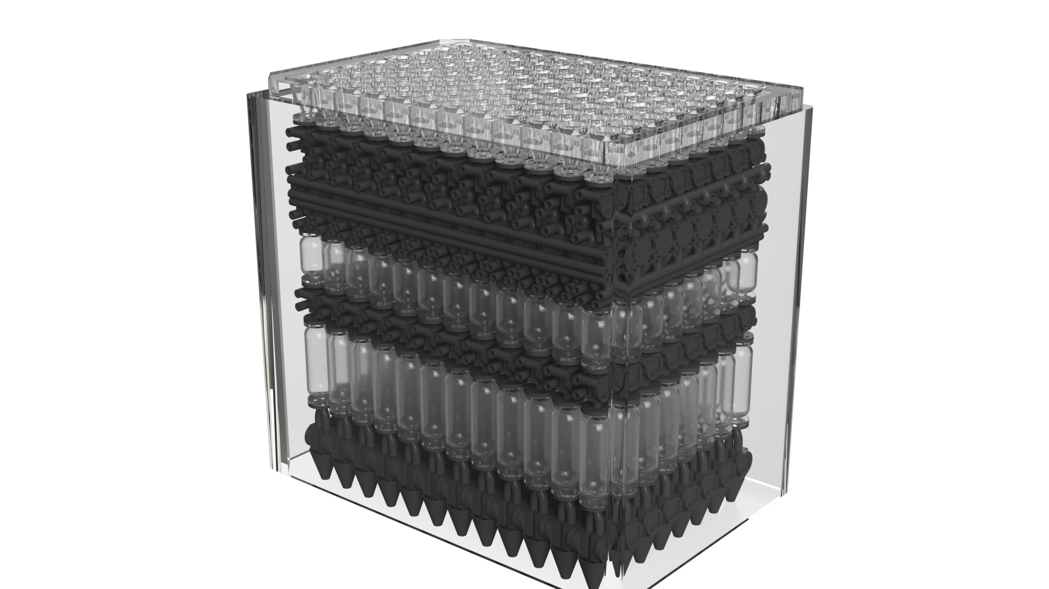

Figure 1: 3D Printed Cell Free Protein Synthesis Multiplexing Device

