Receptor-like kinases at the initiation and maintenance of AM symbiosis
Chai Hao Chiu, Héctor Montero Sommerfeld
Department of Plant Sciences, Cambridge CB2 3EA.
Email addresses: chc59@cam.ac.uk; hm530@cam.ac.uk

Team Members
Chai Hao Chiu, Department of Plant Sciences, University of Cambridge
Chai Hao is a 1st Year PhD student at the Department of Plant Sciences, and was a Part II student in the department (2016-17). He works on the initiation of arbuscular mycorrhizal symbiosis and will be involved in the design of Golden Gate modules, generation of constructs and phenotyping of transgenic plants.

Héctor Montero Sommerfeld, Department of Plant Sciences, University of Cambridge
Héctor is a 2nd Year PhD student at the Department of Plant Sciences. He works on a new family of kinase that maintain the arbuscular mycorrhizal symbiosis, and will be designing, generating the constructs and phenotyping the transgenic plants.
Uta Paszkowski, Department of Plant Sciences, University of Cambridge

Summary of Proposal
We propose a synthetic biology approach to investigate the where and how receptor kinase signalling operates in arbuscular mycorrhizal (AM) symbiosis. Two different receptor kinases regulate the initiation and maintenance of AM symbiosis, respectively. Synthesizing regulatory cis-elements, sub-domains and variants of these receptor kinase will enable the elucidation of kinase signalling, including the conservation of signalling mechanisms across the plant kingdom.

The Idea:
A ubiquitous and ecologically-significant symbiosis develops between most clades of land plants and arbuscular mycorrhizal fungi (AMF). This intimate endosymbiosis developed early in the evolution of land plants and recent phylogenetic studies revealed the presence of a ‘symbiotic toolkit’ that can be traced further back to the charophytes. Components of this symbiotic toolkit have also been shown to be required for other biotic associations in the rhizosphere that have evolved subsequently. These range from beneficial nodulation symbiosis to pathogenic hemibiotrophs like Magnaporthe spp.

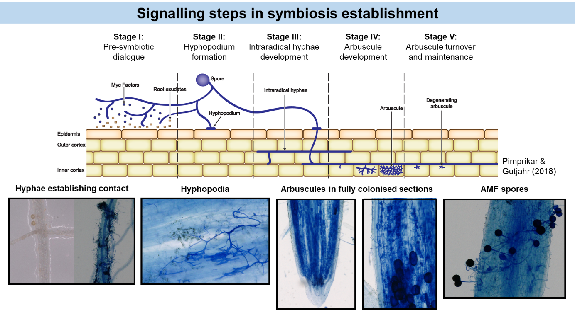
Figure 1: Signalling in arbuscular mycorrhizal symbiosis (AMS). Receptor-like kinases regulate the establishment and maintenance of the symbiosis, regulating the early stages of pre-symbiotic dialogue (by OsCERK1) as well as arbuscule turnover (by OsARK1). This OpenPlant proposal encompasses a synthetic biology approach to better understand the cell biology and biochemical mechanism of these receptor-like kinases. Top graphics modified from Pimprikar and Gutjahr (2018) to update the different stages of AM symbiosis, bottom microscopy images are from the authors (C.H. Chiu)

Amongst the key signalling components involved in arbuscular mycorrhizal symbiosis are receptor-like kinases that perceive hitherto unknown extracellular stimuli and transduce these signals into intracellular responses. Of particular interest are lysin-motif (LysM) receptor kinases and a new family of symbiosis-specific receptor kinases, both of which are found in land plants that develop symbiosis with AMF. In our model organism, rice, the LysM receptor kinase CERK1 is required for the perception and accommodation of both beneficial and pathogenic fungi; whereas the symbiotic-specific kinase ARK1 regulates the maintenance and longevity of the symbiosis. In addition, both receptor kinases appear to be key signalling nodes in their respective processes, each requiring the concerted action of unknown co-receptors that perceive their respective extracellular stimuli.
Following the identification of their symbiotic roles, further investigations into their biochemical mechanisms and cell biology at the early and late stages of symbiosis will reveal mechanistic insights of receptor kinase signalling in roots.

Aims: Here we propose to understand the mechanisms of receptor kinase signalling via two main approaches, both involving DNA synthesis of Golden Gate modules for subsequent cloning and transformations. Creating chimeric receptors and receptor variants is laborious using traditional cloning methods. The Golden Gate modules created would accelerate the assembly, transformation and biological characterisation of symbiotic signalling in roots significantly.

- Assessing tissue-specificity of gene expression and kinase activity
Transcriptional (promoter) and translational fusions of ARK1, CERK1 to appropriate reporters will be generated to identify the tissues and cell-types where the relevant fungal signals are perceived. Using innovative imaging approaches developed in the Paszkowski lab, the expression and localisation of the kinases can then be elucidated with confocal microscopy, and, if useful, with immunogold labelling techniques in electron microscopy.

- Assessing conservation of kinase residues and phosphorylation sites in symbiotic signalling
LysM receptor kinases have expanded and diversified in their functions in the evolution of land plants but are key to the perception of carbohydrate signals, whereas the ARK1 family of receptor kinases are conserved in arbuscular mycorrhizal (AM) hosts and lost in non-AM lineages. Comparisons of the kinase and extra-cellular domains across sequenced genomes have yielded sites and domains of interest in the protein kinases that may be linked to their function. Generation of domains (e.g. individual LysM domains, kinase (sub-)domains) and respective variants will enable rapid generation of constructs that can be used for transformation and phenotyping.

Benefits and Outcomes
Scientifically, results from this project will provide key insights on the evolution, development and signalling mechanisms of arbuscular mycorrhizal symbiosis. In particular, we expect the reporter lines to reveal the tissues and sites of signalling – an area where better understanding is desirable.
In addition, the synthetic biology approach to systematically dissect the mechanisms and sites of signalling for two receptor kinases in a specified biological process benefits from the power and modularity of Golden Gate cloning. The set of modules (specifically kinase domains and variants) generated will be of immense benefit to research groups working not only on symbiosis but also immunity and carbohydrate signalling, given the key role of LysM receptor kinases in both aspects.
To this end, these new kinase/LysM modules will enable researches in both Cambridge and Norwich to identify key organ sites, domains and (co-)receptors in the immunity/symbiosis signalling network. The LysM domain modules will also benefit researchers in carbohydrate signalling. Similarly, material generated for ARK1 is expected to accelerate the understanding of its signalling mechanism in a unique subcellular environment, the peri-arbuscular membrane; and allow us to extend the observations in rice to other plant species, from Medicago truncatula to Marchantia palaecea.

Sponsor for the research and cost centre
Uta Paszkowski
Group Leader and Reader in Plant Molecular Genetics
Department of Plant Sciences, Cambridge CB2 3EA
Cost-code: PDAG/409

I confirm that I have the full support of the sponsor listed above and that they can be added to the OpenPlant Fund mailing list to receive project updates (to which they can unsubscribe at any time).

Budget

Golden gate cloning- £3000
Includes gene synthesis and production of modules for all constructs in this project, followed by transformations and sequencing of constructs to verify
Arbuscular mycorrhizal phenotyping and microscopy for tissue/sub-cellular localisation - £1000
Including consumables, biological material, growth space, phenotyping, molecular confirmation of transgene expression and finally microscopy for characterising transcriptional and translational reporters.
Total budget- £4000

